**NABA/MovieLabs SDR/HDR Display Luminance Study**

As a co-venture, NABA, MovieLabs and NBCUniversal will be conducting a display luminance survey at the DTG Zoo in London. The survey will give us a better understanding of consumer viewing conditions as it relates to „single-master UHD production which has a core production in HDR and generates SDR video for secondary transmission to our SDR viewers (the largest client base).

The testing will allow us to understand the typical consumer viewing experience and also the tone-mapping behavior given specific video formats like SDR, PQ, and HLG.

Given the fact that technical viewing for SDR is traditionally at a luminance level of 100cd/m2 (because of legacy standards built around CRT’s), but consumer viewing is more commonly at higher luminance levels, we will be able to statistically understand what those levels are through this survey.

Additionally, limited testing has shown that there is “midtone“ stretching in some picture modes of SDR displays and we expect similar behavior in HDR, but we have no idea the degree of stretching for SDR and tone mapping in HDR.

We are asking for volunteers to participate in the testing process that will be performed in London starting the week of January 16th for 5 days.

The DTG Zoo has 185 TV’s set up in a lab for testing and measurement. We will be performing the following tests:

* **SDR Luminance Measurements:**
  + **Peak White and two midgray values in the most common picture modes:**
    - *Standard, Cinema/Movie, Sports, Natural, Standard* etc.
  + **HDR (native reference levels as defined in ITU-R BT.2408)**
    - 3,930.5 cd/m2 (90%) **PQ ONLY**
    - 1,000cd/m2 (most common peak white in live workflows/Normalized HLG)
    - 203cd/m2 (graphic/reference white)
    - 26cd/m2 (Midgray)

**All the instructions, media files and survey links are included in the Github README file and the repository here:**

**<https://github.com/digitaltvguy/SDR-HDR-Display-Luminance-Survey>**

Understanding what display mode is most common for SDR consumer viewing, combined with the results of the expert measurements in the survey results, will allow us to understand how images will be viewed and/or tonemapped between HDR and SDR.

The surveys include SDR still graphics files for full range RGB testing and YCbCr movies for narrow range testing of SDR and HDR. Still graphics files currently have no support for HDR signaling and therefore are not useful for the HDR testing. Please use the movie files for HDR.

**There are three surveys to choose from:**

* + **Survey 1: SDR Simple Display MODE Survey for ANYONE**
  + **Survey 2: SDR Luminance Measurement Survey (requires SPOT meter)**
  + **Survey 3: HDR Luminance Measurement Survey (requires SPOT meter)**

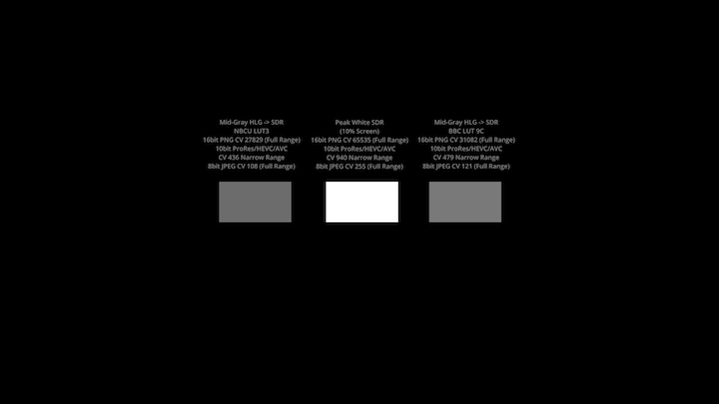

**HDR Test File Thumbnail Preview**